JAMMU AND KASHMIR TEMPLE
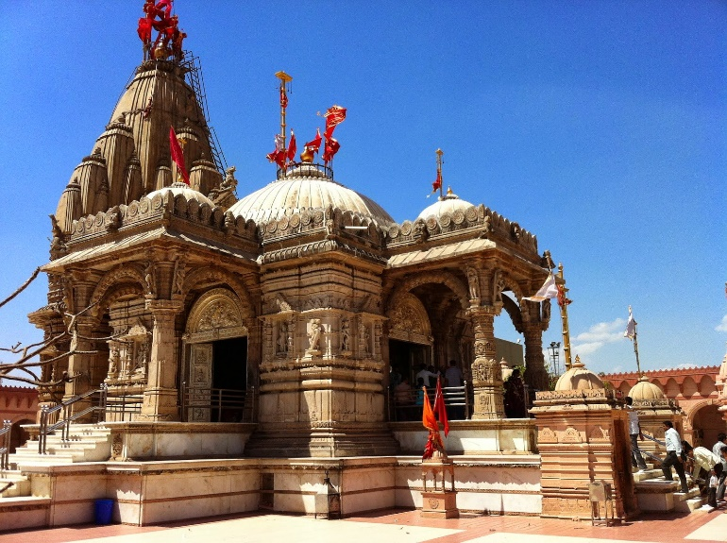

The famous temples in Jammu and Kashmir like Vaishno Devi Temple, Amarnath Temple, and Shankaracharya Temple are revered by millions each year. The region’s spiritual energy, combined with its scenic landscapes, makes it a sought-after destination for both pilgrims and tourists
TAMIL NADU TEMPLE


Tamil Nadu is renowned for its rich cultural heritage and is home to some of the most famous and ancient temples in India. These temples are not only important religious centers but also architectural marvels, showcasing the Dravidian style of architecture.

JAMMU AND KASHMIR MONUMENTS
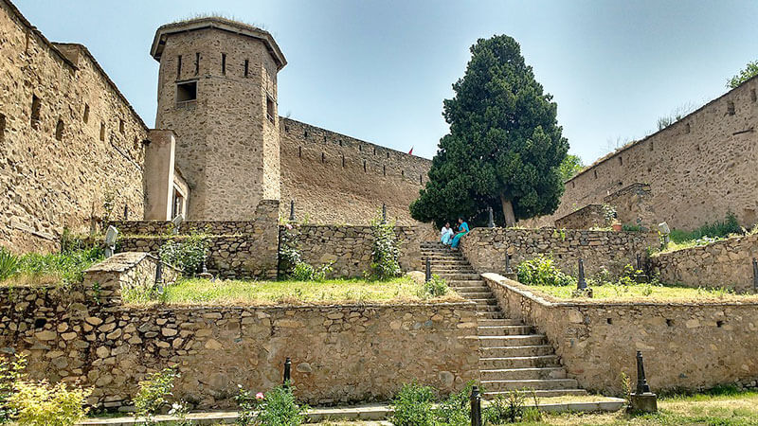

Jammu and Kashmir, located in the northernmost region of India, is home to a rich and diverse cultural heritage. The region boasts a blend of ancient temples, mosques, palaces, forts, and other monuments that reflect its historical significance and the varied influences of different dynasties, religions, and cultures.

TAMIL NADU MONUMENTS


Tamil Nadu is a state rich in history, culture, and architectural heritage. The state is home to numerous ancient monuments, including temples, forts, palaces, and colonial buildings that reflect its long and diverse history. These monuments are a testament to the state's cultural and architectural significance, spanning different dynasties and periods.

JAMMU AND KASHMIR FORT

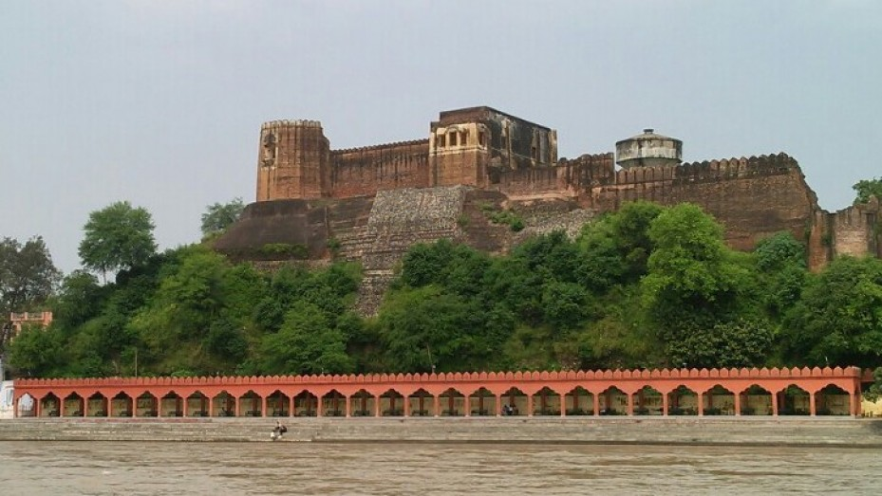

Jammu and Kashmir, with its rich history and strategic location, is home to several historic forts that reflect the region's cultural, architectural, and military heritage. These forts were built by various rulers over the centuries, including the Rajputs, Mughals, and Dogras, to protect the region from invaders and as symbols of power.

TAMIL NADU FORT
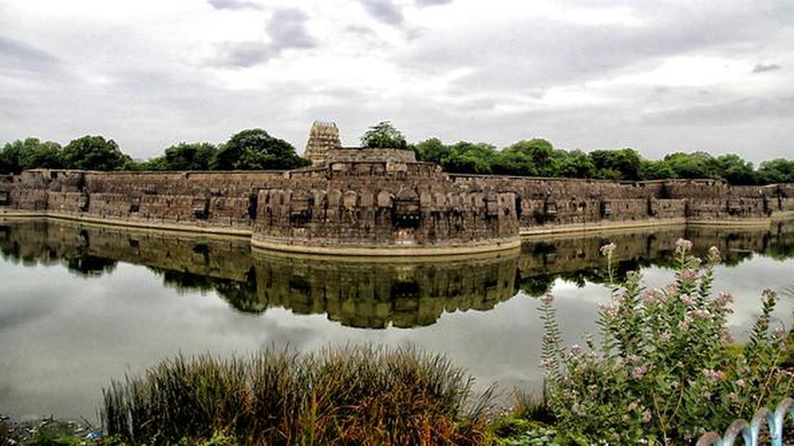

Tamil Nadu is home to numerous forts that have stood as symbols of the region’s historical, military, and architectural heritage. These forts were constructed over several centuries, primarily by dynasties such as the Cholas, Vijayanagar Empire, Nayaks, and the British. Many of these forts served as military strongholds, royal residences, and strategic defense points.

